Tf-idf
Stop words
Stop words are common words (like “the”, “is”, “at”) that are typically filtered out
Stop words can help such as removing “and” “or” etc
Skiciti learn (min df) removing words that appear in too few documents
Skiciti learn Max df removing words that appear in too many documents
We need to understand and use min max df carefully since it So the real trade-off worth thinking about is: min_df is meant to filter out noise (typos, one-off junk tokens), but it can't distinguish "junk that appears once" from "a rare but meaningful term that appears once." Setting min_df too aggressively risks throwing away exactly the kind of word that would have made an article's vector distinctive. That's a legitimate reason to keep min_df conservative (2 or 3, not 10+)

Document frequency DF
Document Number of times the word x is present in all documents, if X is in 3 documents then the DF is 3, this is NOT the amount of times the word appears in one document.
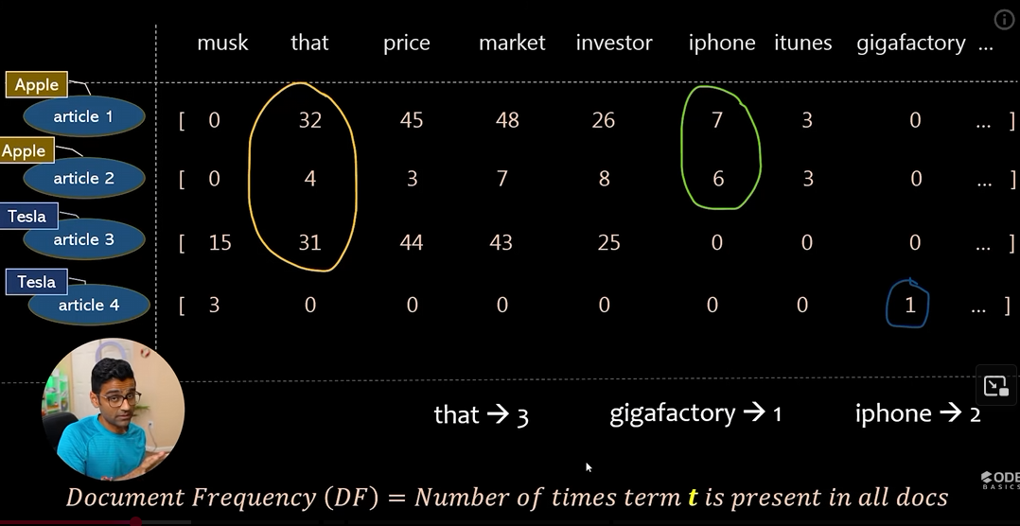
Figure 1
- For example in this scrrenshot, that appears in 3 documents so its DF is 3.
- Same with Iphgone, it appears in 2 documents so the DF is 2
- Same with gigafactory it appears in one item so its TF is 1
So this mean I a words DF is high we should lower its influence since it has no uqnieuness to a documents category since it appears in all documents across many different categories.
Inverse document frequneyc
Same as document frequency but instead of giving it a value of appears in 2 out of 4 documents so 2, we inverse it for example (figure 2) 4 ( total corpus item count)/ (amount of items the word appears in.
For example (figure 1)
“That” appears in 4/3 documents so 4/3 = 1.33 (low = common)
“Iphone” appears in 4/2 documents so that is 2 (2 = average middle seen count)
“gigafactory” appears in 4/1 documents so that is 4 (high = rare)
3 = 1.33 since outr of 4 documents it appears 3 times so the invese score is 1.33
Figure 2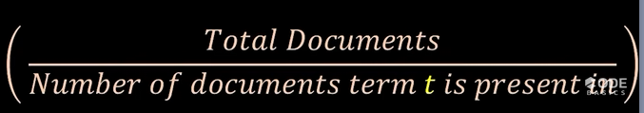
Log to ensure non massive numbers ( do we need ot know this more not really imo)
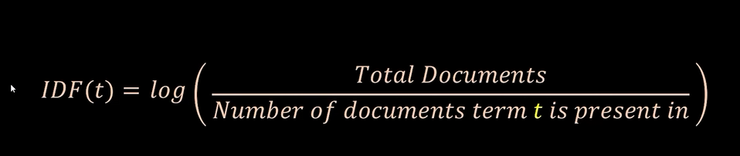
Term frequency
TF is the amount of times a word is mentioned with one documents divided by rhe amount of total words in the document (figure 4 below)
For example figure one the word “market” appears 48 times with the total words in the document at 0+32+45+48+26+77+3+0 = 23, so end result would be 48/231
Figure 4
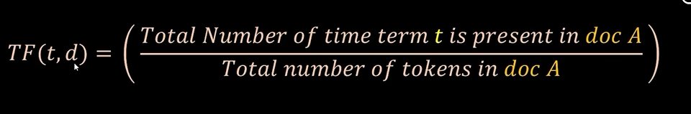

TF-IDF
In the end, TF-DF is the multiplication of these two terms (TF) * (IDF) (figure x) to balance how often a word appears inside a single document against how rare or common that same word is across all documents
